In this lab we will see connectivity between two different VPCs by using peering. We will check before and after connectivity between VMs in different VPCs

**Make sure ICMP port is open in both VPC before stating**

Create one Vm in default VPC and once VM in MyVpc

Login to vm in my VPC and ping private IP address of Default VPC’s Vm

Before any peering, we are not able to communicate between vms in two different vpc by using its private IP

But if we use public IP, then it works because it travels through Internet, but we need to establish internal connectivity

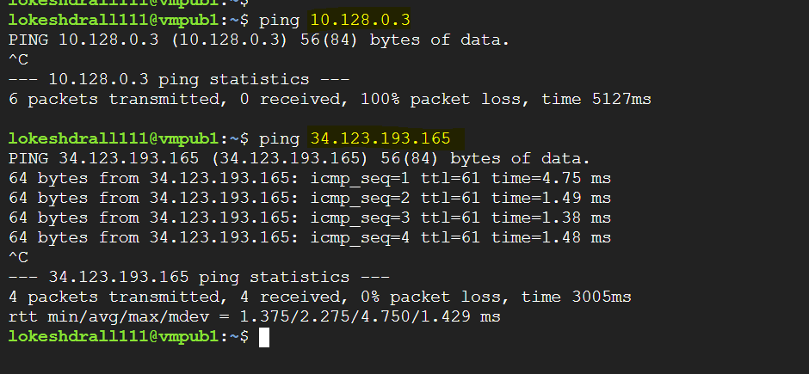

Now let’s do the peering

Go to VPC dashboard and click VPC Network Peering

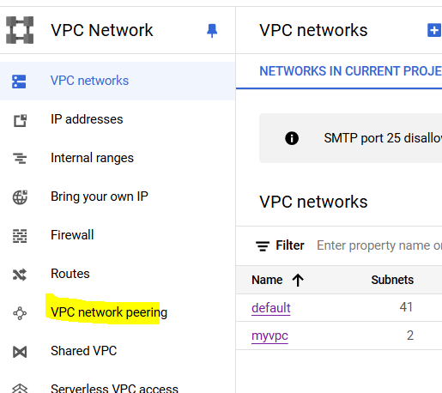

Give peering name, select both VPC and keep rest default

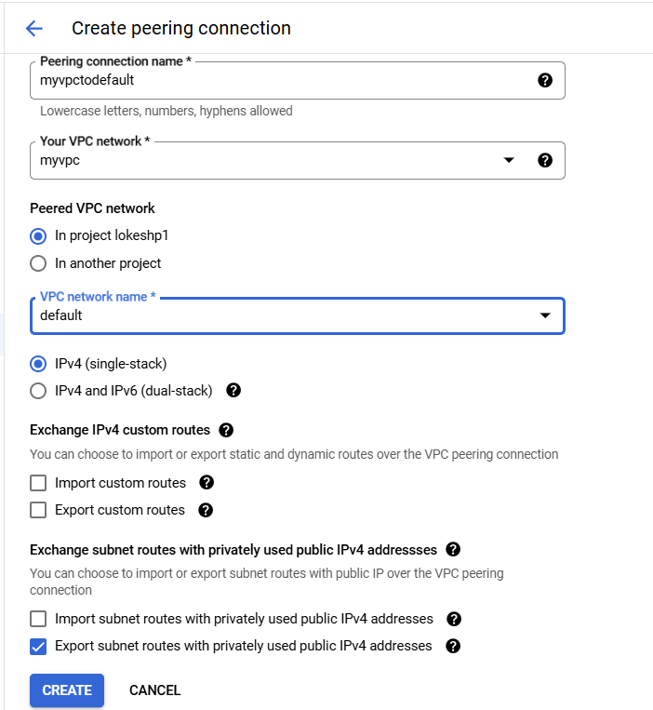

Once created, it will show as inactive state and message, to make it active we need to make an peering connection other way as well

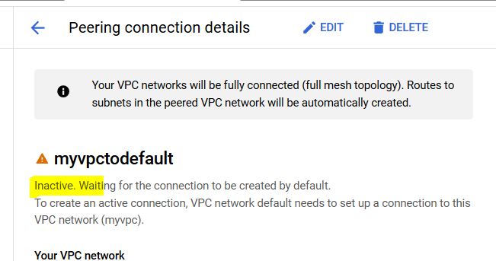

Similarly make a peering connection from default to myvpc

As soon we create second peering connection, both status will show as Active

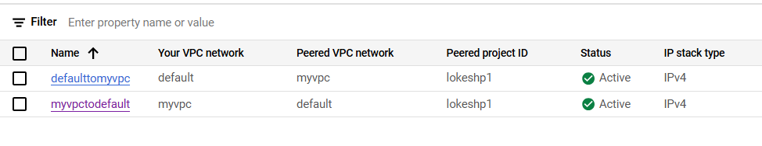

Now again try to ping the private Ip and this will work this time.

